# 总体交叉验证结果

## 模型1

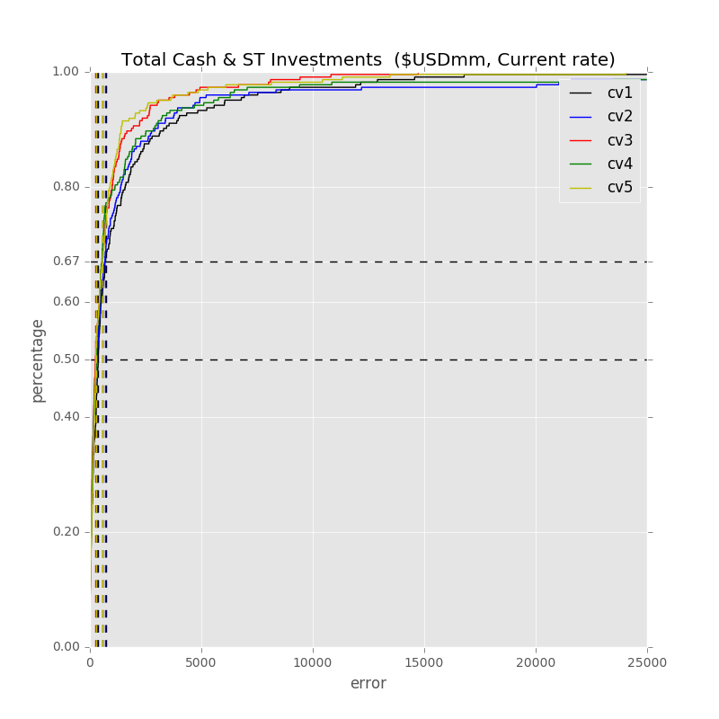

Label: Total Cash & ST Investments ($USDmm, Current rate)

Min Error: 0.215313

Mean Error: 1477.964262

Median Error: 373.000737

Max Error: 56007.525324

Feature importance:

Total Assets ($USDmm, Current rate): 0.034897

Cash from Ops. ($USDmm, Current rate): 0.034877

Net Income ($USDmm, Current rate): 0.033186

Rev YOY % : 0.032333

Cash from Ops./EBITDA % : 0.031283

Net Property, Plant & Equipment/ Total Assets % : 0.029717

EBITDA ($USDmm, Current rate): 0.028609

Return on Equity % : 0.028515

Total Liabilities/Total Assets % : 0.028257

Total Revenue ($USDmm, Current rate): 0.028112

Cash Acquisitions ($USDmm, Current rate): 0.027916

Cash from Ops./Net Income% : 0.027781

Avg. Days Payable Out. (Days): 0.027561

Net Property, Plant & Equipment ($USDmm, Current rate): 0.027537

Avg. Days Sales Out. (Days): 0.027476

Net Income Margin % : 0.027474

Total Asset Turnover : 0.027049

Avg. Cash Conversion Cycle (Days): 0.027001

EBITDA Margin % : 0.026940

Capital Expenditure ($USDmm, Current rate): 0.026851

R&D Exp. ($USDmm, Current rate): 0.026505

Cost Of Goods Sold ($USDmm, Current rate): 0.026466

Other Operating Exp. Total ($USDmm, Current rate): 0.026413

Total Liabilities ($USDmm, Current rate): 0.025722

Return on Assets % : 0.025543

Goodwill/Total Revenue % : 0.025178

Avg. Days Inventory Out. (Days): 0.025037

Depreciation & Amort., Total ($USDmm, Current rate): 0.025017

Repurchase of Common Stock ($USDmm, Current rate): 0.024811

Goodwill ($USDmm, Current rate): 0.024735

Gross Margin % : 0.024672

Total Debt/Equity % : 0.022435

R&D Exp./Total Revenue % : 0.022292

Payout Ratio (%): 0.021542

Cash Acquisitions/Total Revenue % : 0.019359

Number of Employees / Total Revenue [LTM] (Latest): 0.014460

Year Founded: 0.014271

Issuer Credit Rating - Foreign Currency LT [Latest] (Rating): 0.009187

准入资本市场难度: 0.003992

Development Phase : 0.002707

Industry Dummy: 0.002667

Share Bonus : 0.002226

Cash flow risk(0:low; 1: high): 0.001389

Label: Total Cash & ST Investments ($USDmm, Current rate)

Min Error: 0.735842

Mean Error: 1734.880464

Median Error: 306.997863

Max Error: 60513.379122

Feature importance:

Rev YOY % : 0.034681

Net Income ($USDmm, Current rate): 0.033302

Cash from Ops./Net Income% : 0.032083

Total Assets ($USDmm, Current rate): 0.030608

Avg. Days Sales Out. (Days): 0.029626

Cash from Ops./EBITDA % : 0.029518

Capital Expenditure ($USDmm, Current rate): 0.029389

EBITDA ($USDmm, Current rate): 0.029122

Net Property, Plant & Equipment/ Total Assets % : 0.028992

Total Liabilities/Total Assets % : 0.028775

Cash from Ops. ($USDmm, Current rate): 0.028590

Other Operating Exp. Total ($USDmm, Current rate): 0.028265

Depreciation & Amort., Total ($USDmm, Current rate): 0.027823

Avg. Cash Conversion Cycle (Days): 0.027743

Net Income Margin % : 0.027576

Total Liabilities ($USDmm, Current rate): 0.027481

Return on Equity % : 0.027061

Total Asset Turnover : 0.027047

Total Revenue ($USDmm, Current rate): 0.026814

Avg. Days Payable Out. (Days): 0.026614

Return on Assets % : 0.026583

Cost Of Goods Sold ($USDmm, Current rate): 0.026201

Goodwill ($USDmm, Current rate): 0.026067

R&D Exp. ($USDmm, Current rate): 0.025986

EBITDA Margin % : 0.025630

Cash Acquisitions ($USDmm, Current rate): 0.025627

Net Property, Plant & Equipment ($USDmm, Current rate): 0.025377

Repurchase of Common Stock ($USDmm, Current rate): 0.024823

R&D Exp./Total Revenue % : 0.023554

Avg. Days Inventory Out. (Days): 0.023462

Total Debt/Equity % : 0.022949

Payout Ratio (%): 0.022563

Gross Margin % : 0.022044

Goodwill/Total Revenue % : 0.021298

Cash Acquisitions/Total Revenue % : 0.020288

Number of Employees / Total Revenue [LTM] (Latest): 0.017903

Year Founded: 0.017546

Issuer Credit Rating - Foreign Currency LT [Latest] (Rating): 0.008499

准入资本市场难度: 0.003875

Development Phase : 0.002583

Share Bonus : 0.002511

Industry Dummy: 0.002047

Cash flow risk(0:low; 1: high): 0.001475

Label: Total Cash & ST Investments ($USDmm, Current rate)

Min Error: 0.049373

Mean Error: 815.678104

Median Error: 253.561071

Max Error: 14732.169927

Feature importance:

Net Income ($USDmm, Current rate): 0.036018

Cash from Ops. ($USDmm, Current rate): 0.033851

Rev YOY % : 0.033059

Cash from Ops./Net Income% : 0.031821

Capital Expenditure ($USDmm, Current rate): 0.030800

Cash from Ops./EBITDA % : 0.030380

EBITDA ($USDmm, Current rate): 0.030320

Total Asset Turnover : 0.030318

Total Assets ($USDmm, Current rate): 0.029953

Return on Equity % : 0.029823

Net Property, Plant & Equipment/ Total Assets % : 0.028594

Total Liabilities/Total Assets % : 0.028127

Total Liabilities ($USDmm, Current rate): 0.027534

Cost Of Goods Sold ($USDmm, Current rate): 0.027506

Avg. Days Sales Out. (Days): 0.027505

EBITDA Margin % : 0.027405

Avg. Days Payable Out. (Days): 0.027213

Other Operating Exp. Total ($USDmm, Current rate): 0.027054

Depreciation & Amort., Total ($USDmm, Current rate): 0.026693

Net Income Margin % : 0.026643

Return on Assets % : 0.026636

R&D Exp. ($USDmm, Current rate): 0.026207

Total Debt/Equity % : 0.025938

Gross Margin % : 0.025555

Total Revenue ($USDmm, Current rate): 0.025510

Avg. Cash Conversion Cycle (Days): 0.025208

Goodwill ($USDmm, Current rate): 0.024669

Repurchase of Common Stock ($USDmm, Current rate): 0.024413

Avg. Days Inventory Out. (Days): 0.023310

Cash Acquisitions ($USDmm, Current rate): 0.023165

Net Property, Plant & Equipment ($USDmm, Current rate): 0.023053

Goodwill/Total Revenue % : 0.022960

R&D Exp./Total Revenue % : 0.021634

Payout Ratio (%): 0.020195

Cash Acquisitions/Total Revenue % : 0.018435

Year Founded: 0.016047

Number of Employees / Total Revenue [LTM] (Latest): 0.015776

Issuer Credit Rating - Foreign Currency LT [Latest] (Rating): 0.007060

准入资本市场难度: 0.003653

Industry Dummy: 0.003008

Development Phase : 0.002663

Share Bonus : 0.002402

Cash flow risk(0:low; 1: high): 0.001884

Label: Total Cash & ST Investments ($USDmm, Current rate)

Min Error: 0.105729

Mean Error: 1446.186581

Median Error: 292.510930

Max Error: 48624.718626

Feature importance:

Total Assets ($USDmm, Current rate): 0.032991

Cash from Ops./Net Income% : 0.031388

Cash from Ops. ($USDmm, Current rate): 0.030748

R&D Exp. ($USDmm, Current rate): 0.030418

Avg. Days Sales Out. (Days): 0.030385

Rev YOY % : 0.030258

EBITDA ($USDmm, Current rate): 0.030240

Net Income ($USDmm, Current rate): 0.029845

Other Operating Exp. Total ($USDmm, Current rate): 0.029797

Total Liabilities ($USDmm, Current rate): 0.029533

Return on Equity % : 0.028532

Capital Expenditure ($USDmm, Current rate): 0.028507

Cash from Ops./EBITDA % : 0.028162

Total Asset Turnover : 0.028125

Avg. Days Payable Out. (Days): 0.027912

Avg. Cash Conversion Cycle (Days): 0.027628

Net Property, Plant & Equipment/ Total Assets % : 0.027577

Net Income Margin % : 0.027454

Cost Of Goods Sold ($USDmm, Current rate): 0.027190

EBITDA Margin % : 0.027084

Total Liabilities/Total Assets % : 0.026994

Depreciation & Amort., Total ($USDmm, Current rate): 0.026819

Return on Assets % : 0.026725

Total Revenue ($USDmm, Current rate): 0.026505

Gross Margin % : 0.025129

Cash Acquisitions ($USDmm, Current rate): 0.025072

Avg. Days Inventory Out. (Days): 0.024717

Net Property, Plant & Equipment ($USDmm, Current rate): 0.024554

Total Debt/Equity % : 0.023750

Goodwill ($USDmm, Current rate): 0.023463

Repurchase of Common Stock ($USDmm, Current rate): 0.023424

Goodwill/Total Revenue % : 0.022848

R&D Exp./Total Revenue % : 0.022662

Cash Acquisitions/Total Revenue % : 0.020565

Payout Ratio (%): 0.019038

Year Founded: 0.018306

Number of Employees / Total Revenue [LTM] (Latest): 0.016319

Issuer Credit Rating - Foreign Currency LT [Latest] (Rating): 0.008031

准入资本市场难度: 0.002760

Industry Dummy: 0.002753

Development Phase : 0.002396

Share Bonus : 0.001936

Cash flow risk(0:low; 1: high): 0.001459

Label: Total Cash & ST Investments ($USDmm, Current rate)

Min Error: 0.504083

Mean Error: 1434.005119

Median Error: 265.608948

Max Error: 128706.450202

Feature importance:

Total Assets ($USDmm, Current rate): 0.034437

Cash from Ops. ($USDmm, Current rate): 0.034274

Net Income ($USDmm, Current rate): 0.033350

EBITDA ($USDmm, Current rate): 0.031705

Other Operating Exp. Total ($USDmm, Current rate): 0.030996

Cash from Ops./EBITDA % : 0.030932

Rev YOY % : 0.029974

Cash Acquisitions ($USDmm, Current rate): 0.029369

Net Income Margin % : 0.029366

Cash from Ops./Net Income% : 0.029190

Return on Equity % : 0.028454

Net Property, Plant & Equipment/ Total Assets % : 0.027958

Total Liabilities ($USDmm, Current rate): 0.027750

Cost Of Goods Sold ($USDmm, Current rate): 0.027548

Avg. Days Payable Out. (Days): 0.027525

Avg. Days Sales Out. (Days): 0.027364

Return on Assets % : 0.027179

R&D Exp. ($USDmm, Current rate): 0.027178

EBITDA Margin % : 0.026920

Depreciation & Amort., Total ($USDmm, Current rate): 0.026870

Capital Expenditure ($USDmm, Current rate): 0.026762

Total Asset Turnover : 0.026457

Total Debt/Equity % : 0.026314

Goodwill ($USDmm, Current rate): 0.025794

Total Liabilities/Total Assets % : 0.025603

Total Revenue ($USDmm, Current rate): 0.025516

Avg. Cash Conversion Cycle (Days): 0.024111

Net Property, Plant & Equipment ($USDmm, Current rate): 0.023421

Gross Margin % : 0.022413

Repurchase of Common Stock ($USDmm, Current rate): 0.021952

R&D Exp./Total Revenue % : 0.021602

Avg. Days Inventory Out. (Days): 0.021457

Goodwill/Total Revenue % : 0.021220

Payout Ratio (%): 0.021064

Cash Acquisitions/Total Revenue % : 0.019882

Number of Employees / Total Revenue [LTM] (Latest): 0.018106

Year Founded: 0.018105

Issuer Credit Rating - Foreign Currency LT [Latest] (Rating): 0.007997

准入资本市场难度: 0.003888

Industry Dummy: 0.003033

Development Phase : 0.002557

Share Bonus : 0.002335

Cash flow risk(0:low; 1: high): 0.002069

Total Min: 0.322068

Total Mean: 1381.742906

Total Median: 298.335910

Total Max: 61716.848640

## 模型2

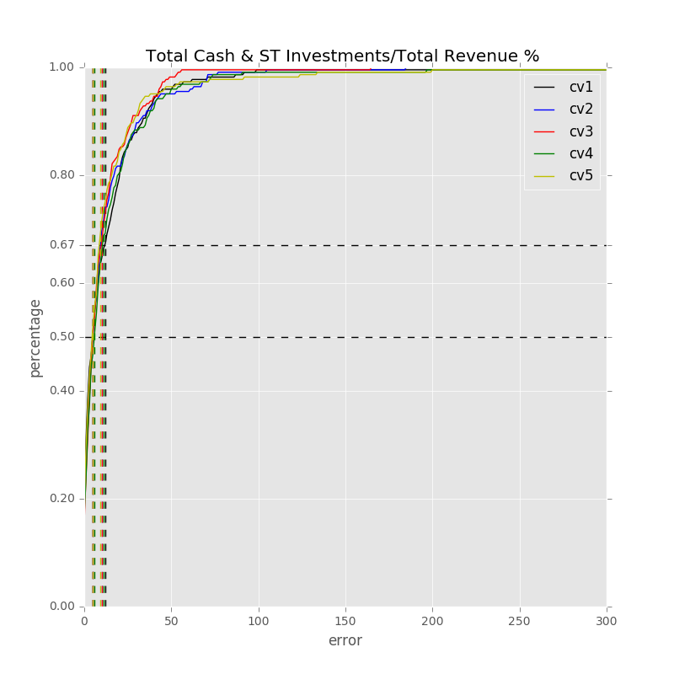

Label: Total Cash & ST Investments/Total Revenue %

Min Error: 0.000925

Mean Error: 17.771542

Median Error: 5.950642

Max Error: 831.976032

Feature importance:

Net Income Margin % : 0.037964

Rev YOY % : 0.037761

EBITDA Margin % : 0.034759

Avg. Cash Conversion Cycle (Days): 0.033490

Cash from Ops./EBITDA % : 0.033316

Return on Assets % : 0.032569

Gross Margin % : 0.031897

Cash from Ops./Net Income% : 0.031661

Net Property, Plant & Equipment/ Total Assets % : 0.030802

R&D Exp./Total Revenue % : 0.030096

Total Liabilities/Total Assets % : 0.029132

Total Liabilities ($USDmm, Current rate): 0.028790

Avg. Days Sales Out. (Days): 0.028190

Total Asset Turnover : 0.028117

Return on Equity % : 0.027205

Total Revenue ($USDmm, Current rate): 0.026730

Avg. Days Payable Out. (Days): 0.026150

Total Assets ($USDmm, Current rate): 0.026091

Other Operating Exp. Total ($USDmm, Current rate): 0.025361

EBITDA ($USDmm, Current rate): 0.025150

Cost Of Goods Sold ($USDmm, Current rate): 0.025133

Goodwill/Total Revenue % : 0.025057

Total Debt/Equity % : 0.024932

Net Income ($USDmm, Current rate): 0.024622

Cash from Ops. ($USDmm, Current rate): 0.023297

Capital Expenditure ($USDmm, Current rate): 0.023103

Net Property, Plant & Equipment ($USDmm, Current rate): 0.023022

Depreciation & Amort., Total ($USDmm, Current rate): 0.022832

Repurchase of Common Stock ($USDmm, Current rate): 0.022599

Avg. Days Inventory Out. (Days): 0.021503

Goodwill ($USDmm, Current rate): 0.021461

Cash Acquisitions ($USDmm, Current rate): 0.020459

Cash Acquisitions/Total Revenue % : 0.020259

Payout Ratio (%): 0.020225

R&D Exp. ($USDmm, Current rate): 0.019463

Year Founded: 0.016443

Number of Employees / Total Revenue [LTM] (Latest): 0.015780

Issuer Credit Rating - Foreign Currency LT [Latest] (Rating): 0.009349

准入资本市场难度: 0.004694

Development Phase : 0.003249

Industry Dummy: 0.003245

Share Bonus : 0.002200

Cash flow risk(0:low; 1: high): 0.001840

Label: Total Cash & ST Investments/Total Revenue %

Min Error: 0.002214

Mean Error: 12.658752

Median Error: 5.857796

Max Error: 185.376872

Feature importance:

Net Income Margin % : 0.040025

Rev YOY % : 0.038676

Total Liabilities/Total Assets % : 0.033787

Return on Assets % : 0.033750

Cash from Ops./EBITDA % : 0.033563

Gross Margin % : 0.033562

Cash from Ops./Net Income% : 0.032729

Avg. Cash Conversion Cycle (Days): 0.031840

Avg. Days Sales Out. (Days): 0.030113

Net Property, Plant & Equipment/ Total Assets % : 0.030006

Avg. Days Payable Out. (Days): 0.029734

EBITDA Margin % : 0.029450

Total Asset Turnover : 0.028275

R&D Exp./Total Revenue % : 0.028012

Return on Equity % : 0.027505

Total Liabilities ($USDmm, Current rate): 0.026457

Other Operating Exp. Total ($USDmm, Current rate): 0.025659

Repurchase of Common Stock ($USDmm, Current rate): 0.025563

Net Income ($USDmm, Current rate): 0.025273

Total Revenue ($USDmm, Current rate): 0.025057

Capital Expenditure ($USDmm, Current rate): 0.024858

Total Debt/Equity % : 0.024753

Depreciation & Amort., Total ($USDmm, Current rate): 0.024485

Avg. Days Inventory Out. (Days): 0.024223

Cost Of Goods Sold ($USDmm, Current rate): 0.023710

Net Property, Plant & Equipment ($USDmm, Current rate): 0.023676

Cash from Ops. ($USDmm, Current rate): 0.022893

Total Assets ($USDmm, Current rate): 0.022679

EBITDA ($USDmm, Current rate): 0.022451

Cash Acquisitions ($USDmm, Current rate): 0.020455

R&D Exp. ($USDmm, Current rate): 0.020339

Cash Acquisitions/Total Revenue % : 0.020271

Goodwill/Total Revenue % : 0.020188

Goodwill ($USDmm, Current rate): 0.019183

Year Founded: 0.017778

Payout Ratio (%): 0.017408

Number of Employees / Total Revenue [LTM] (Latest): 0.017035

Issuer Credit Rating - Foreign Currency LT [Latest] (Rating): 0.008525

准入资本市场难度: 0.004568

Development Phase : 0.004040

Industry Dummy: 0.003067

Cash flow risk(0:low; 1: high): 0.002199

Share Bonus : 0.002183

Label: Total Cash & ST Investments/Total Revenue %

Min Error: 0.029836

Mean Error: 11.148476

Median Error: 5.945500

Max Error: 165.932018

Feature importance:

Net Income Margin % : 0.041103

Rev YOY % : 0.036487

Cash from Ops./EBITDA % : 0.034331

Avg. Cash Conversion Cycle (Days): 0.033841

Total Asset Turnover : 0.032308

Cash from Ops./Net Income% : 0.031619

EBITDA Margin % : 0.031185

Total Liabilities/Total Assets % : 0.030893

Net Property, Plant & Equipment/ Total Assets % : 0.030688

Gross Margin % : 0.029498

Avg. Days Sales Out. (Days): 0.029484

R&D Exp./Total Revenue % : 0.028467

Return on Assets % : 0.027986

Total Revenue ($USDmm, Current rate): 0.027890

Return on Equity % : 0.027673

Cost Of Goods Sold ($USDmm, Current rate): 0.026650

Total Liabilities ($USDmm, Current rate): 0.026453

Avg. Days Payable Out. (Days): 0.026369

Capital Expenditure ($USDmm, Current rate): 0.025973

Total Debt/Equity % : 0.025433

Other Operating Exp. Total ($USDmm, Current rate): 0.025295

Depreciation & Amort., Total ($USDmm, Current rate): 0.024872

Cash from Ops. ($USDmm, Current rate): 0.024813

Total Assets ($USDmm, Current rate): 0.024731

Repurchase of Common Stock ($USDmm, Current rate): 0.023758

Net Income ($USDmm, Current rate): 0.023257

Cash Acquisitions ($USDmm, Current rate): 0.022663

Net Property, Plant & Equipment ($USDmm, Current rate): 0.022583

EBITDA ($USDmm, Current rate): 0.022218

Avg. Days Inventory Out. (Days): 0.021383

Goodwill/Total Revenue % : 0.020855

Cash Acquisitions/Total Revenue % : 0.020446

Goodwill ($USDmm, Current rate): 0.020419

R&D Exp. ($USDmm, Current rate): 0.018495

Number of Employees / Total Revenue [LTM] (Latest): 0.018426

Payout Ratio (%): 0.018017

Year Founded: 0.017800

Issuer Credit Rating - Foreign Currency LT [Latest] (Rating): 0.009054

准入资本市场难度: 0.005069

Industry Dummy: 0.004155

Development Phase : 0.003820

Cash flow risk(0:low; 1: high): 0.002194

Share Bonus : 0.001344

Label: Total Cash & ST Investments/Total Revenue %

Min Error: 0.022207

Mean Error: 14.843087

Median Error: 6.692171

Max Error: 425.938289

Feature importance:

Cash from Ops./Net Income% : 0.036144

Net Income Margin % : 0.035376

Rev YOY % : 0.035318

Cash from Ops./EBITDA % : 0.033624

Gross Margin % : 0.031827

Return on Equity % : 0.030960

R&D Exp./Total Revenue % : 0.030575

Avg. Cash Conversion Cycle (Days): 0.030337

Net Property, Plant & Equipment/ Total Assets % : 0.030223

Total Asset Turnover : 0.029568

Avg. Days Sales Out. (Days): 0.029388

Return on Assets % : 0.029276

Total Liabilities/Total Assets % : 0.028940

Total Liabilities ($USDmm, Current rate): 0.027768

Avg. Days Payable Out. (Days): 0.027600

EBITDA Margin % : 0.027329

Capital Expenditure ($USDmm, Current rate): 0.027326

Total Revenue ($USDmm, Current rate): 0.027093

Other Operating Exp. Total ($USDmm, Current rate): 0.027043

Total Assets ($USDmm, Current rate): 0.025902

Net Income ($USDmm, Current rate): 0.025057

EBITDA ($USDmm, Current rate): 0.024912

Cash from Ops. ($USDmm, Current rate): 0.024779

Cost Of Goods Sold ($USDmm, Current rate): 0.024015

Total Debt/Equity % : 0.023681

Cash Acquisitions/Total Revenue % : 0.023203

Depreciation & Amort., Total ($USDmm, Current rate): 0.023199

Net Property, Plant & Equipment ($USDmm, Current rate): 0.022825

Repurchase of Common Stock ($USDmm, Current rate): 0.022383

Avg. Days Inventory Out. (Days): 0.022305

Goodwill/Total Revenue % : 0.021751

Cash Acquisitions ($USDmm, Current rate): 0.021480

Goodwill ($USDmm, Current rate): 0.020676

Payout Ratio (%): 0.020361

Year Founded: 0.020116

Number of Employees / Total Revenue [LTM] (Latest): 0.018401

R&D Exp. ($USDmm, Current rate): 0.017420

Issuer Credit Rating - Foreign Currency LT [Latest] (Rating): 0.007273

准入资本市场难度: 0.003927

Development Phase : 0.003346

Industry Dummy: 0.003104

Share Bonus : 0.002304

Cash flow risk(0:low; 1: high): 0.001866

Label: Total Cash & ST Investments/Total Revenue %

Min Error: 0.005323

Mean Error: 13.976739

Median Error: 5.586336

Max Error: 529.147003

Feature importance:

Rev YOY % : 0.036659

Net Income Margin % : 0.036579

Cash from Ops./Net Income% : 0.034345

Cash from Ops./EBITDA % : 0.033942

Net Property, Plant & Equipment/ Total Assets % : 0.032680

R&D Exp./Total Revenue % : 0.031918

Total Liabilities/Total Assets % : 0.031171

Avg. Cash Conversion Cycle (Days): 0.031084

Total Asset Turnover : 0.030749

Gross Margin % : 0.029794

Return on Assets % : 0.029142

EBITDA Margin % : 0.028812

Avg. Days Sales Out. (Days): 0.028577

Avg. Days Payable Out. (Days): 0.028509

Return on Equity % : 0.028495

Total Liabilities ($USDmm, Current rate): 0.028305

Total Assets ($USDmm, Current rate): 0.027566

Net Income ($USDmm, Current rate): 0.025971

Total Revenue ($USDmm, Current rate): 0.025488

Cost Of Goods Sold ($USDmm, Current rate): 0.025380

EBITDA ($USDmm, Current rate): 0.025116

Other Operating Exp. Total ($USDmm, Current rate): 0.024559

Total Debt/Equity % : 0.024139

Net Property, Plant & Equipment ($USDmm, Current rate): 0.024086

Cash from Ops. ($USDmm, Current rate): 0.023316

Repurchase of Common Stock ($USDmm, Current rate): 0.022931

Avg. Days Inventory Out. (Days): 0.022715

Goodwill ($USDmm, Current rate): 0.022243

Goodwill/Total Revenue % : 0.021738

Capital Expenditure ($USDmm, Current rate): 0.021664

Cash Acquisitions ($USDmm, Current rate): 0.021636

Payout Ratio (%): 0.021324

Depreciation & Amort., Total ($USDmm, Current rate): 0.020932

R&D Exp. ($USDmm, Current rate): 0.020649

Cash Acquisitions/Total Revenue % : 0.019833

Year Founded: 0.017777

Number of Employees / Total Revenue [LTM] (Latest): 0.017714

Issuer Credit Rating - Foreign Currency LT [Latest] (Rating): 0.008653

准入资本市场难度: 0.003894

Development Phase : 0.003525

Industry Dummy: 0.003261

Share Bonus : 0.001713

Cash flow risk(0:low; 1: high): 0.001420

Total Min: 0.012101

Total Mean: 14.079719

Total Median: 6.006489

Total Max: 427.674043

## 模型3

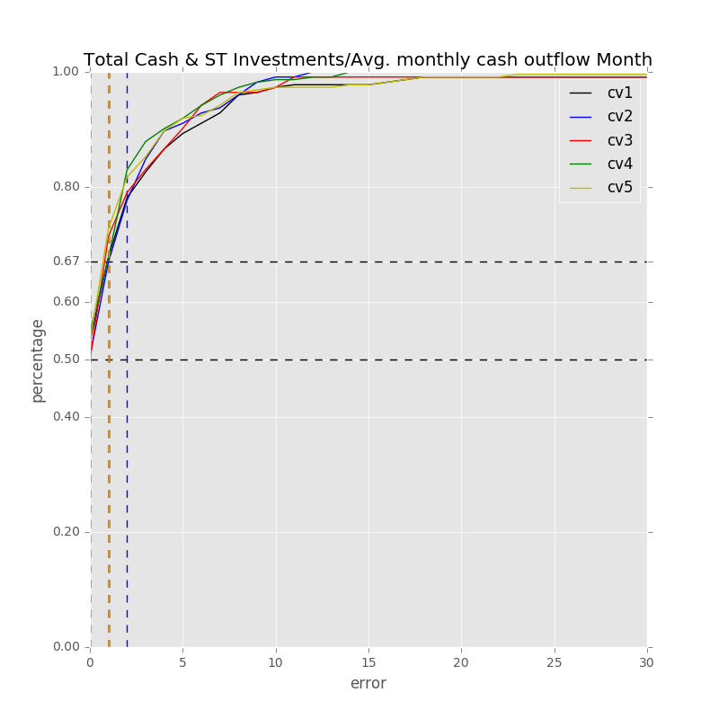

Label: Total Cash & ST Investments/Avg. monthly cash outflow Month

Min Error: 0.000566

Mean Error: 2.394725

Median Error: 0.872405

Max Error: 38.242270

Feature importance:

Net Income Margin % : 0.038230

Rev YOY % : 0.038016

Cash from Ops./EBITDA % : 0.034248

Return on Assets % : 0.033629

Total Liabilities/Total Assets % : 0.033219

Gross Margin % : 0.032843

Total Asset Turnover : 0.032716

Cash from Ops./Net Income% : 0.031497

EBITDA Margin % : 0.030351

Avg. Cash Conversion Cycle (Days): 0.030308

Net Property, Plant & Equipment/ Total Assets % : 0.029987

Return on Equity % : 0.028800

Total Revenue ($USDmm, Current rate): 0.028668

Capital Expenditure ($USDmm, Current rate): 0.027581

Total Assets ($USDmm, Current rate): 0.026267

Depreciation & Amort., Total ($USDmm, Current rate): 0.026128

Avg. Days Sales Out. (Days): 0.025508

Repurchase of Common Stock ($USDmm, Current rate): 0.025456

Net Property, Plant & Equipment ($USDmm, Current rate): 0.025379

R&D Exp./Total Revenue % : 0.025366

EBITDA ($USDmm, Current rate): 0.025287

Total Liabilities ($USDmm, Current rate): 0.025073

Avg. Days Payable Out. (Days): 0.025053

Cash from Ops. ($USDmm, Current rate): 0.024639

Avg. Days Inventory Out. (Days): 0.023107

Total Debt/Equity % : 0.023075

Cost Of Goods Sold ($USDmm, Current rate): 0.022957

Other Operating Exp. Total ($USDmm, Current rate): 0.022825

Cash Acquisitions ($USDmm, Current rate): 0.022083

Net Income ($USDmm, Current rate): 0.021991

Goodwill/Total Revenue % : 0.021900

Goodwill ($USDmm, Current rate): 0.021314

Payout Ratio (%): 0.021255

Cash Acquisitions/Total Revenue % : 0.019943

R&D Exp. ($USDmm, Current rate): 0.018544

Number of Employees / Total Revenue [LTM] (Latest): 0.017582

Year Founded: 0.016050

Issuer Credit Rating - Foreign Currency LT [Latest] (Rating): 0.008233

Development Phase : 0.004105

准入资本市场难度: 0.004099

Industry Dummy: 0.002962

Share Bonus : 0.002025

Cash flow risk(0:low; 1: high): 0.001701

Label: Total Cash & ST Investments/Avg. monthly cash outflow Month

Min Error: 0.000829

Mean Error: 2.019335

Median Error: 0.993786

Max Error: 12.424633

Feature importance:

Rev YOY % : 0.036811

Net Income Margin % : 0.036713

Cash from Ops./EBITDA % : 0.035943

EBITDA Margin % : 0.033402

Cash from Ops./Net Income% : 0.032116

Gross Margin % : 0.031701

Avg. Cash Conversion Cycle (Days): 0.031692

Total Liabilities/Total Assets % : 0.030724

Return on Equity % : 0.030569

Avg. Days Sales Out. (Days): 0.030530

Total Asset Turnover : 0.029695

Net Property, Plant & Equipment/ Total Assets % : 0.029575

Return on Assets % : 0.029101

Capital Expenditure ($USDmm, Current rate): 0.027456

Avg. Days Payable Out. (Days): 0.027147

Total Liabilities ($USDmm, Current rate): 0.026762

Other Operating Exp. Total ($USDmm, Current rate): 0.026614

Net Income ($USDmm, Current rate): 0.026507

Total Revenue ($USDmm, Current rate): 0.026356

Cash from Ops. ($USDmm, Current rate): 0.026259

Cost Of Goods Sold ($USDmm, Current rate): 0.025920

Depreciation & Amort., Total ($USDmm, Current rate): 0.024699

Total Assets ($USDmm, Current rate): 0.024656

EBITDA ($USDmm, Current rate): 0.024550

R&D Exp./Total Revenue % : 0.024223

Goodwill/Total Revenue % : 0.024204

Total Debt/Equity % : 0.021874

Avg. Days Inventory Out. (Days): 0.021749

Net Property, Plant & Equipment ($USDmm, Current rate): 0.021169

Goodwill ($USDmm, Current rate): 0.021158

Cash Acquisitions/Total Revenue % : 0.021129

Repurchase of Common Stock ($USDmm, Current rate): 0.020554

Cash Acquisitions ($USDmm, Current rate): 0.020514

R&D Exp. ($USDmm, Current rate): 0.019890

Payout Ratio (%): 0.019655

Number of Employees / Total Revenue [LTM] (Latest): 0.017648

Year Founded: 0.016642

Issuer Credit Rating - Foreign Currency LT [Latest] (Rating): 0.007908

准入资本市场难度: 0.004928

Industry Dummy: 0.004040

Development Phase : 0.003409

Share Bonus : 0.002041

Cash flow risk(0:low; 1: high): 0.001763

Label: Total Cash & ST Investments/Avg. monthly cash outflow Month

Min Error: 0.002799

Mean Error: 2.261469

Median Error: 1.006102

Max Error: 45.996268

Feature importance:

Rev YOY % : 0.040270

Net Income Margin % : 0.037042

Cash from Ops./EBITDA % : 0.034525

EBITDA Margin % : 0.033145

Total Liabilities/Total Assets % : 0.032376

Return on Assets % : 0.031527

Cash from Ops./Net Income% : 0.031108

Net Property, Plant & Equipment/ Total Assets % : 0.031016

Avg. Cash Conversion Cycle (Days): 0.030492

Gross Margin % : 0.029828

Total Asset Turnover : 0.029311

Avg. Days Sales Out. (Days): 0.028853

R&D Exp./Total Revenue % : 0.028444

Total Revenue ($USDmm, Current rate): 0.027764

Return on Equity % : 0.027156

Avg. Days Payable Out. (Days): 0.026092

Capital Expenditure ($USDmm, Current rate): 0.026053

Net Income ($USDmm, Current rate): 0.025758

Total Liabilities ($USDmm, Current rate): 0.025638

Repurchase of Common Stock ($USDmm, Current rate): 0.025307

Total Assets ($USDmm, Current rate): 0.025277

Cost Of Goods Sold ($USDmm, Current rate): 0.024446

Depreciation & Amort., Total ($USDmm, Current rate): 0.024262

Total Debt/Equity % : 0.024137

Cash from Ops. ($USDmm, Current rate): 0.023762

Other Operating Exp. Total ($USDmm, Current rate): 0.023446

Goodwill/Total Revenue % : 0.023389

R&D Exp. ($USDmm, Current rate): 0.023172

Net Property, Plant & Equipment ($USDmm, Current rate): 0.022401

EBITDA ($USDmm, Current rate): 0.022104

Cash Acquisitions ($USDmm, Current rate): 0.022028

Cash Acquisitions/Total Revenue % : 0.021507

Avg. Days Inventory Out. (Days): 0.021028

Goodwill ($USDmm, Current rate): 0.020892

Payout Ratio (%): 0.019652

Number of Employees / Total Revenue [LTM] (Latest): 0.018380

Year Founded: 0.016324

Issuer Credit Rating - Foreign Currency LT [Latest] (Rating): 0.008398

Development Phase : 0.003699

Industry Dummy: 0.003330

准入资本市场难度: 0.003087

Cash flow risk(0:low; 1: high): 0.001958

Share Bonus : 0.001619

Label: Total Cash & ST Investments/Avg. monthly cash outflow Month

Min Error: 0.000276

Mean Error: 2.011882

Median Error: 0.805187

Max Error: 46.045728

Feature importance:

Rev YOY % : 0.037476

Net Income Margin % : 0.036415

Gross Margin % : 0.034068

Cash from Ops./EBITDA % : 0.032626

Total Asset Turnover : 0.032552

EBITDA Margin % : 0.031687

Net Property, Plant & Equipment/ Total Assets % : 0.031342

Cash from Ops./Net Income% : 0.030825

Avg. Cash Conversion Cycle (Days): 0.030622

Total Liabilities/Total Assets % : 0.029544

R&D Exp./Total Revenue % : 0.028971

Return on Assets % : 0.028825

Avg. Days Sales Out. (Days): 0.028696

Avg. Days Payable Out. (Days): 0.027163

Total Revenue ($USDmm, Current rate): 0.026904

Total Debt/Equity % : 0.026805

Return on Equity % : 0.026542

Total Assets ($USDmm, Current rate): 0.026362

Total Liabilities ($USDmm, Current rate): 0.025945

Net Income ($USDmm, Current rate): 0.025865

Capital Expenditure ($USDmm, Current rate): 0.025670

Cost Of Goods Sold ($USDmm, Current rate): 0.025348

Other Operating Exp. Total ($USDmm, Current rate): 0.024448

Cash Acquisitions ($USDmm, Current rate): 0.024446

Cash from Ops. ($USDmm, Current rate): 0.024206

Repurchase of Common Stock ($USDmm, Current rate): 0.024116

Goodwill/Total Revenue % : 0.023386

Avg. Days Inventory Out. (Days): 0.022735

EBITDA ($USDmm, Current rate): 0.022506

Cash Acquisitions/Total Revenue % : 0.022296

Depreciation & Amort., Total ($USDmm, Current rate): 0.022277

Net Property, Plant & Equipment ($USDmm, Current rate): 0.021323

Goodwill ($USDmm, Current rate): 0.020740

R&D Exp. ($USDmm, Current rate): 0.020503

Payout Ratio (%): 0.018956

Year Founded: 0.017847

Number of Employees / Total Revenue [LTM] (Latest): 0.017796

Issuer Credit Rating - Foreign Currency LT [Latest] (Rating): 0.008245

Industry Dummy: 0.004101

准入资本市场难度: 0.003991

Development Phase : 0.002960

Share Bonus : 0.001724

Cash flow risk(0:low; 1: high): 0.001145

Label: Total Cash & ST Investments/Avg. monthly cash outflow Month

Min Error: 0.001156

Mean Error: 2.156037

Median Error: 0.903423

Max Error: 40.112118

Feature importance:

Net Income Margin % : 0.038989

Rev YOY % : 0.036741

Cash from Ops./EBITDA % : 0.036268

Total Liabilities/Total Assets % : 0.033429

EBITDA Margin % : 0.031267

Avg. Cash Conversion Cycle (Days): 0.031206

Gross Margin % : 0.030549

Cash from Ops./Net Income% : 0.030412

Return on Assets % : 0.029934

Avg. Days Payable Out. (Days): 0.029489

Total Asset Turnover : 0.029299

Net Property, Plant & Equipment/ Total Assets % : 0.029270

Avg. Days Sales Out. (Days): 0.028600

Capital Expenditure ($USDmm, Current rate): 0.028573

Return on Equity % : 0.028067

R&D Exp./Total Revenue % : 0.027768

Cash from Ops. ($USDmm, Current rate): 0.026084

Net Income ($USDmm, Current rate): 0.026076

Total Revenue ($USDmm, Current rate): 0.025573

Total Assets ($USDmm, Current rate): 0.025454

Cost Of Goods Sold ($USDmm, Current rate): 0.025280

Repurchase of Common Stock ($USDmm, Current rate): 0.025268

Total Debt/Equity % : 0.024739

Total Liabilities ($USDmm, Current rate): 0.024377

Net Property, Plant & Equipment ($USDmm, Current rate): 0.023152

EBITDA ($USDmm, Current rate): 0.022738

Depreciation & Amort., Total ($USDmm, Current rate): 0.022722

Avg. Days Inventory Out. (Days): 0.022509

Cash Acquisitions/Total Revenue % : 0.022198

Goodwill/Total Revenue % : 0.022146

Other Operating Exp. Total ($USDmm, Current rate): 0.021760

Cash Acquisitions ($USDmm, Current rate): 0.021222

Goodwill ($USDmm, Current rate): 0.021073

Payout Ratio (%): 0.019807

R&D Exp. ($USDmm, Current rate): 0.019653

Year Founded: 0.017798

Number of Employees / Total Revenue [LTM] (Latest): 0.017075

Issuer Credit Rating - Foreign Currency LT [Latest] (Rating): 0.007930

Industry Dummy: 0.004376

准入资本市场难度: 0.004153

Share Bonus : 0.002469

Development Phase : 0.002340

Cash flow risk(0:low; 1: high): 0.002168

Total Min: 0.001125

Total Mean: 2.168690

Total Median: 0.916181

Total Max: 36.564203

## 模型4

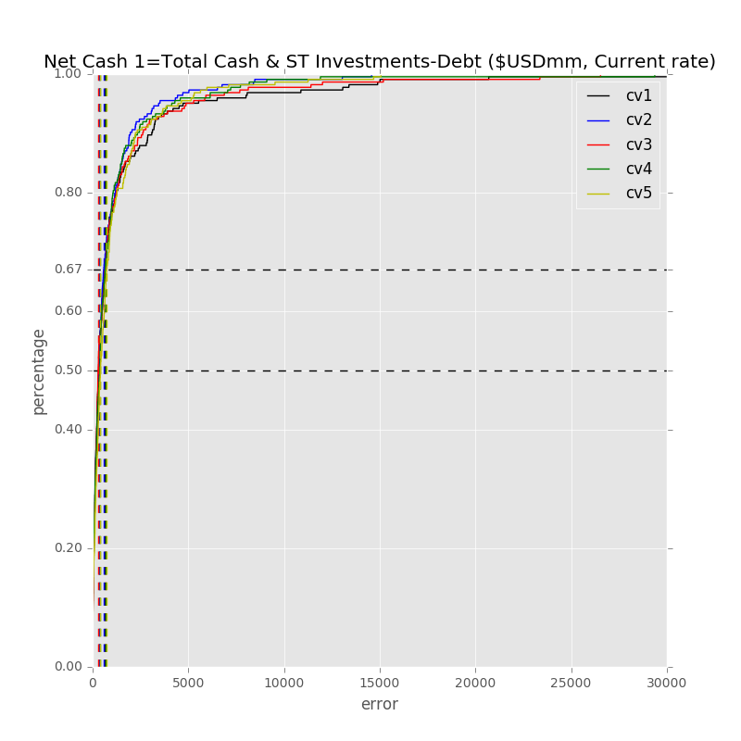

Label: Net Cash 1=Total Cash & ST Investments-Debt ($USDmm, Current rate)

Min Error: 0.043792

Mean Error: 1383.289688

Median Error: 321.254217

Max Error: 52791.613913

Feature importance:

Net Property, Plant & Equipment/ Total Assets % : 0.033749

Total Liabilities/Total Assets % : 0.033096

Total Debt/Equity % : 0.032521

Cash from Ops. ($USDmm, Current rate): 0.031784

Total Liabilities ($USDmm, Current rate): 0.031137

Total Assets ($USDmm, Current rate): 0.030623

Cost Of Goods Sold ($USDmm, Current rate): 0.029523

Capital Expenditure ($USDmm, Current rate): 0.029221

Depreciation & Amort., Total ($USDmm, Current rate): 0.028963

Rev YOY % : 0.028893

Other Operating Exp. Total ($USDmm, Current rate): 0.028684

Cash from Ops./Net Income% : 0.028649

Net Income ($USDmm, Current rate): 0.028607

Total Revenue ($USDmm, Current rate): 0.028040

Return on Equity % : 0.028000

Avg. Days Sales Out. (Days): 0.027802

Return on Assets % : 0.027455

Total Asset Turnover : 0.027431

Cash from Ops./EBITDA % : 0.027345

Avg. Days Payable Out. (Days): 0.026743

EBITDA ($USDmm, Current rate): 0.026427

EBITDA Margin % : 0.026373

Net Income Margin % : 0.026051

Net Property, Plant & Equipment ($USDmm, Current rate): 0.025791

Avg. Cash Conversion Cycle (Days): 0.025773

Gross Margin % : 0.025555

Cash Acquisitions ($USDmm, Current rate): 0.024016

Goodwill ($USDmm, Current rate): 0.023987

Avg. Days Inventory Out. (Days): 0.023512

Goodwill/Total Revenue % : 0.022842

Repurchase of Common Stock ($USDmm, Current rate): 0.022818

R&D Exp. ($USDmm, Current rate): 0.022450

Year Founded: 0.019589

R&D Exp./Total Revenue % : 0.019428

Cash Acquisitions/Total Revenue % : 0.019385

Payout Ratio (%): 0.018597

Number of Employees / Total Revenue [LTM] (Latest): 0.017172

Issuer Credit Rating - Foreign Currency LT [Latest] (Rating): 0.007895

准入资本市场难度: 0.004329

Industry Dummy: 0.003123

Development Phase : 0.002533

Share Bonus : 0.002334

Cash flow risk(0:low; 1: high): 0.001752

Label: Net Cash 1=Total Cash & ST Investments-Debt ($USDmm, Current rate)

Min Error: 0.033037

Mean Error: 886.612101

Median Error: 332.781200

Max Error: 14571.304942

Feature importance:

Net Income ($USDmm, Current rate): 0.033327

Cash from Ops. ($USDmm, Current rate): 0.033174

Total Debt/Equity % : 0.032413

Total Liabilities/Total Assets % : 0.032412

Cash from Ops./Net Income% : 0.031713

Rev YOY % : 0.031229

Total Revenue ($USDmm, Current rate): 0.030872

Total Asset Turnover : 0.030306

Total Assets ($USDmm, Current rate): 0.030171

Avg. Days Sales Out. (Days): 0.030135

Other Operating Exp. Total ($USDmm, Current rate): 0.029699

Total Liabilities ($USDmm, Current rate): 0.028938

Cost Of Goods Sold ($USDmm, Current rate): 0.028868

Net Income Margin % : 0.028483

Cash from Ops./EBITDA % : 0.028457

Net Property, Plant & Equipment/ Total Assets % : 0.028438

Return on Assets % : 0.028336

Net Property, Plant & Equipment ($USDmm, Current rate): 0.028025

Capital Expenditure ($USDmm, Current rate): 0.027833

EBITDA ($USDmm, Current rate): 0.027586

Return on Equity % : 0.026324

Gross Margin % : 0.025528

Avg. Cash Conversion Cycle (Days): 0.024606

EBITDA Margin % : 0.024603

Goodwill ($USDmm, Current rate): 0.024011

Repurchase of Common Stock ($USDmm, Current rate): 0.023697

Avg. Days Payable Out. (Days): 0.023634

Cash Acquisitions ($USDmm, Current rate): 0.023280

Avg. Days Inventory Out. (Days): 0.023197

Depreciation & Amort., Total ($USDmm, Current rate): 0.023151

R&D Exp. ($USDmm, Current rate): 0.022618

Goodwill/Total Revenue % : 0.022040

Payout Ratio (%): 0.019527

Cash Acquisitions/Total Revenue % : 0.018900

R&D Exp./Total Revenue % : 0.018853

Year Founded: 0.016382

Number of Employees / Total Revenue [LTM] (Latest): 0.016330

Issuer Credit Rating - Foreign Currency LT [Latest] (Rating): 0.007358

准入资本市场难度: 0.004879

Industry Dummy: 0.003333

Development Phase : 0.002766

Share Bonus : 0.002488

Cash flow risk(0:low; 1: high): 0.002082

Label: Net Cash 1=Total Cash & ST Investments-Debt ($USDmm, Current rate)

Min Error: 0.033061

Mean Error: 1183.210616

Median Error: 289.442740

Max Error: 26531.988052

Feature importance:

Total Debt/Equity % : 0.036694

Total Liabilities/Total Assets % : 0.033943

Cash from Ops./Net Income% : 0.032908

Rev YOY % : 0.032179

Cash from Ops. ($USDmm, Current rate): 0.031664

Net Income ($USDmm, Current rate): 0.031510

Total Assets ($USDmm, Current rate): 0.031314

Net Property, Plant & Equipment/ Total Assets % : 0.030055

EBITDA ($USDmm, Current rate): 0.029533

Total Asset Turnover : 0.029441

Other Operating Exp. Total ($USDmm, Current rate): 0.029359

Avg. Days Sales Out. (Days): 0.028463

Avg. Days Payable Out. (Days): 0.027939

Cost Of Goods Sold ($USDmm, Current rate): 0.027897

Return on Equity % : 0.027740

Capital Expenditure ($USDmm, Current rate): 0.027481

Total Revenue ($USDmm, Current rate): 0.027464

Total Liabilities ($USDmm, Current rate): 0.027292

Return on Assets % : 0.027141

EBITDA Margin % : 0.026467

Avg. Cash Conversion Cycle (Days): 0.026445

Cash from Ops./EBITDA % : 0.026240

Net Income Margin % : 0.026016

Repurchase of Common Stock ($USDmm, Current rate): 0.025568

Depreciation & Amort., Total ($USDmm, Current rate): 0.025561

Avg. Days Inventory Out. (Days): 0.025155

Gross Margin % : 0.025075

Cash Acquisitions ($USDmm, Current rate): 0.024649

Net Property, Plant & Equipment ($USDmm, Current rate): 0.024482

R&D Exp. ($USDmm, Current rate): 0.022441

Payout Ratio (%): 0.022330

Goodwill ($USDmm, Current rate): 0.021298

Goodwill/Total Revenue % : 0.020438

Cash Acquisitions/Total Revenue % : 0.018106

R&D Exp./Total Revenue % : 0.017803

Number of Employees / Total Revenue [LTM] (Latest): 0.015523

Year Founded: 0.014563

Issuer Credit Rating - Foreign Currency LT [Latest] (Rating): 0.007439

准入资本市场难度: 0.004644

Industry Dummy: 0.003012

Development Phase : 0.002964

Share Bonus : 0.002340

Cash flow risk(0:low; 1: high): 0.001422

Label: Net Cash 1=Total Cash & ST Investments-Debt ($USDmm, Current rate)

Min Error: 0.370533

Mean Error: 1023.781018

Median Error: 382.762738

Max Error: 29363.505181

Feature importance:

Total Debt/Equity % : 0.033187

Cash from Ops. ($USDmm, Current rate): 0.031633

Total Liabilities/Total Assets % : 0.031549

Cash from Ops./EBITDA % : 0.031160

Rev YOY % : 0.030837

Cash from Ops./Net Income% : 0.030499

Net Property, Plant & Equipment/ Total Assets % : 0.030116

Net Income ($USDmm, Current rate): 0.029983

Total Assets ($USDmm, Current rate): 0.029841

Total Asset Turnover : 0.029321

EBITDA ($USDmm, Current rate): 0.029078

Total Liabilities ($USDmm, Current rate): 0.028824

Capital Expenditure ($USDmm, Current rate): 0.028703

Net Income Margin % : 0.028430

Return on Assets % : 0.027796

Depreciation & Amort., Total ($USDmm, Current rate): 0.027646

Avg. Days Payable Out. (Days): 0.027568

Other Operating Exp. Total ($USDmm, Current rate): 0.027536

EBITDA Margin % : 0.027227

Return on Equity % : 0.027195

Avg. Cash Conversion Cycle (Days): 0.026862

R&D Exp. ($USDmm, Current rate): 0.026239

Total Revenue ($USDmm, Current rate): 0.026023

Avg. Days Sales Out. (Days): 0.025938

Goodwill ($USDmm, Current rate): 0.025776

Cost Of Goods Sold ($USDmm, Current rate): 0.025415

Repurchase of Common Stock ($USDmm, Current rate): 0.025315

Cash Acquisitions ($USDmm, Current rate): 0.024355

Gross Margin % : 0.024167

Net Property, Plant & Equipment ($USDmm, Current rate): 0.023543

Goodwill/Total Revenue % : 0.021975

Avg. Days Inventory Out. (Days): 0.021771

Cash Acquisitions/Total Revenue % : 0.021756

R&D Exp./Total Revenue % : 0.020125

Payout Ratio (%): 0.018376

Number of Employees / Total Revenue [LTM] (Latest): 0.015150

Year Founded: 0.014211

Issuer Credit Rating - Foreign Currency LT [Latest] (Rating): 0.009184

准入资本市场难度: 0.004052

Cash flow risk(0:low; 1: high): 0.003371

Development Phase : 0.002976

Share Bonus : 0.002736

Industry Dummy: 0.002554

Label: Net Cash 1=Total Cash & ST Investments-Debt ($USDmm, Current rate)

Min Error: 1.450868

Mean Error: 1648.989293

Median Error: 413.894143

Max Error: 134489.193589

Feature importance:

Net Income ($USDmm, Current rate): 0.032073

Rev YOY % : 0.031123

Total Liabilities ($USDmm, Current rate): 0.030891

Total Debt/Equity % : 0.030796

Net Property, Plant & Equipment/ Total Assets % : 0.030722

Total Liabilities/Total Assets % : 0.030719

Cash from Ops. ($USDmm, Current rate): 0.029673

Cash from Ops./Net Income% : 0.029636

Capital Expenditure ($USDmm, Current rate): 0.029633

Cash from Ops./EBITDA % : 0.029160

Total Asset Turnover : 0.028719

Other Operating Exp. Total ($USDmm, Current rate): 0.028593

Total Assets ($USDmm, Current rate): 0.027984

Cost Of Goods Sold ($USDmm, Current rate): 0.027910

EBITDA ($USDmm, Current rate): 0.027824

Avg. Days Sales Out. (Days): 0.027384

Total Revenue ($USDmm, Current rate): 0.027269

Avg. Days Payable Out. (Days): 0.026960

Return on Assets % : 0.026946

Net Property, Plant & Equipment ($USDmm, Current rate): 0.026743

Return on Equity % : 0.026660

Depreciation & Amort., Total ($USDmm, Current rate): 0.026473

Net Income Margin % : 0.026351

EBITDA Margin % : 0.026095

Avg. Cash Conversion Cycle (Days): 0.025934

Cash Acquisitions ($USDmm, Current rate): 0.025525

R&D Exp. ($USDmm, Current rate): 0.025326

Gross Margin % : 0.023555

Goodwill ($USDmm, Current rate): 0.023422

Avg. Days Inventory Out. (Days): 0.022986

Cash Acquisitions/Total Revenue % : 0.022476

Goodwill/Total Revenue % : 0.022348

Repurchase of Common Stock ($USDmm, Current rate): 0.021861

Payout Ratio (%): 0.021473

R&D Exp./Total Revenue % : 0.018134

Number of Employees / Total Revenue [LTM] (Latest): 0.018000

Year Founded: 0.016711

Issuer Credit Rating - Foreign Currency LT [Latest] (Rating): 0.011310

准入资本市场难度: 0.004726

Industry Dummy: 0.003240

Share Bonus : 0.002360

Development Phase : 0.002295

Cash flow risk(0:low; 1: high): 0.001979

Total Min: 0.386258

Total Mean: 1225.176543

Total Median: 348.027008

Total Max: 51549.521136

## 模型5

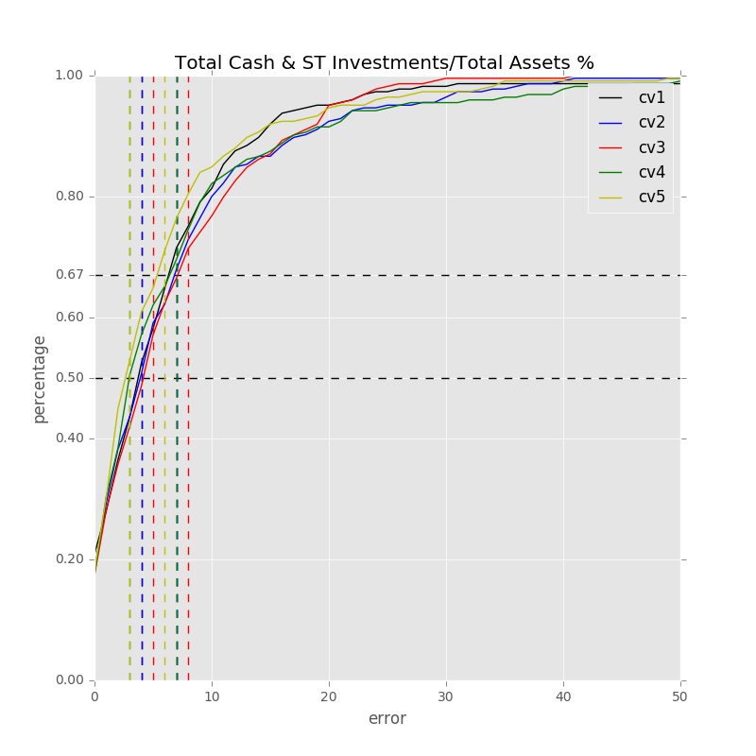

Label: Total Cash & ST Investments/Total Assets %

Min Error: 0.010371

Mean Error: 6.880314

Median Error: 4.792081

Max Error: 71.723133

Feature importance:

Cash from Ops./EBITDA % : 0.037403

Rev YOY % : 0.032995

Cash from Ops./Net Income% : 0.031474

Net Property, Plant & Equipment/ Total Assets % : 0.030392

Total Asset Turnover : 0.030324

Avg. Cash Conversion Cycle (Days): 0.030106

Return on Assets % : 0.029493

Return on Equity % : 0.029403

Total Liabilities/Total Assets % : 0.029278

EBITDA Margin % : 0.028853

Total Assets ($USDmm, Current rate): 0.028090

Net Income Margin % : 0.027761

Gross Margin % : 0.027671

Total Revenue ($USDmm, Current rate): 0.026640

Total Liabilities ($USDmm, Current rate): 0.026494

Total Debt/Equity % : 0.026318

Depreciation & Amort., Total ($USDmm, Current rate): 0.026295

Avg. Days Sales Out. (Days): 0.026168

Net Income ($USDmm, Current rate): 0.025965

Other Operating Exp. Total ($USDmm, Current rate): 0.025811

R&D Exp./Total Revenue % : 0.025486

Cash from Ops. ($USDmm, Current rate): 0.025020

R&D Exp. ($USDmm, Current rate): 0.024740

EBITDA ($USDmm, Current rate): 0.024682

Net Property, Plant & Equipment ($USDmm, Current rate): 0.024494

Capital Expenditure ($USDmm, Current rate): 0.024273

Avg. Days Payable Out. (Days): 0.023632

Cost Of Goods Sold ($USDmm, Current rate): 0.023612

Goodwill ($USDmm, Current rate): 0.023454

Repurchase of Common Stock ($USDmm, Current rate): 0.023324

Number of Employees / Total Revenue [LTM] (Latest): 0.023075

Avg. Days Inventory Out. (Days): 0.022543

Payout Ratio (%): 0.022261

Year Founded: 0.021589

Cash Acquisitions ($USDmm, Current rate): 0.021150

Goodwill/Total Revenue % : 0.020820

Cash Acquisitions/Total Revenue % : 0.020592

Issuer Credit Rating - Foreign Currency LT [Latest] (Rating): 0.009731

准入资本市场难度: 0.006628

Development Phase : 0.004319

Industry Dummy: 0.003479

Cash flow risk(0:low; 1: high): 0.002230

Share Bonus : 0.001930

Label: Total Cash & ST Investments/Total Assets %

Min Error: 0.011697

Mean Error: 7.536467

Median Error: 4.852483

Max Error: 67.312259

Feature importance:

Net Income Margin % : 0.036498

Cash from Ops./EBITDA % : 0.036229

Rev YOY % : 0.035864

Cash from Ops./Net Income% : 0.034750

Return on Assets % : 0.032351

Total Asset Turnover : 0.030179

Avg. Days Sales Out. (Days): 0.029910

Net Property, Plant & Equipment/ Total Assets % : 0.029794

Total Liabilities/Total Assets % : 0.029207

Net Income ($USDmm, Current rate): 0.028391

Total Assets ($USDmm, Current rate): 0.028121

EBITDA Margin % : 0.028117

Avg. Cash Conversion Cycle (Days): 0.027626

Gross Margin % : 0.027389

Return on Equity % : 0.026622

Capital Expenditure ($USDmm, Current rate): 0.026459

Other Operating Exp. Total ($USDmm, Current rate): 0.026276

R&D Exp./Total Revenue % : 0.026236

Total Liabilities ($USDmm, Current rate): 0.026085

Total Revenue ($USDmm, Current rate): 0.025796

Avg. Days Payable Out. (Days): 0.025655

Total Debt/Equity % : 0.024359

Number of Employees / Total Revenue [LTM] (Latest): 0.023877

EBITDA ($USDmm, Current rate): 0.023838

R&D Exp. ($USDmm, Current rate): 0.023716

Cash from Ops. ($USDmm, Current rate): 0.023671

Avg. Days Inventory Out. (Days): 0.023593

Depreciation & Amort., Total ($USDmm, Current rate): 0.023403

Goodwill/Total Revenue % : 0.023130

Year Founded: 0.022603

Repurchase of Common Stock ($USDmm, Current rate): 0.022574

Cost Of Goods Sold ($USDmm, Current rate): 0.022503

Goodwill ($USDmm, Current rate): 0.022046

Cash Acquisitions ($USDmm, Current rate): 0.021193

Net Property, Plant & Equipment ($USDmm, Current rate): 0.020847

Payout Ratio (%): 0.018356

Cash Acquisitions/Total Revenue % : 0.017685

Issuer Credit Rating - Foreign Currency LT [Latest] (Rating): 0.010237

准入资本市场难度: 0.005119

Development Phase : 0.003314

Cash flow risk(0:low; 1: high): 0.002162

Share Bonus : 0.002132

Industry Dummy: 0.002085

Label: Total Cash & ST Investments/Total Assets %

Min Error: 0.020561

Mean Error: 7.524096

Median Error: 5.135314

Max Error: 90.268648

Feature importance:

Cash from Ops./EBITDA % : 0.037732

Rev YOY % : 0.033122

Return on Equity % : 0.031897

Total Asset Turnover : 0.031865

Cash from Ops./Net Income% : 0.031785

Total Liabilities/Total Assets % : 0.031171

Avg. Cash Conversion Cycle (Days): 0.029993

EBITDA Margin % : 0.029578

Other Operating Exp. Total ($USDmm, Current rate): 0.029414

Net Income Margin % : 0.029370

Net Property, Plant & Equipment/ Total Assets % : 0.028707

Return on Assets % : 0.028343

Capital Expenditure ($USDmm, Current rate): 0.028124

Total Revenue ($USDmm, Current rate): 0.027204

Gross Margin % : 0.027042

Avg. Days Sales Out. (Days): 0.026793

Total Assets ($USDmm, Current rate): 0.026775

Net Property, Plant & Equipment ($USDmm, Current rate): 0.026713

Net Income ($USDmm, Current rate): 0.026550

Avg. Days Payable Out. (Days): 0.026315

Total Debt/Equity % : 0.025813

Cash from Ops. ($USDmm, Current rate): 0.025676

Cost Of Goods Sold ($USDmm, Current rate): 0.025517

R&D Exp./Total Revenue % : 0.024683

Total Liabilities ($USDmm, Current rate): 0.024510

Depreciation & Amort., Total ($USDmm, Current rate): 0.024332

Number of Employees / Total Revenue [LTM] (Latest): 0.023963

EBITDA ($USDmm, Current rate): 0.022901

Avg. Days Inventory Out. (Days): 0.022761

Goodwill ($USDmm, Current rate): 0.022454

Repurchase of Common Stock ($USDmm, Current rate): 0.022103

R&D Exp. ($USDmm, Current rate): 0.021425

Goodwill/Total Revenue % : 0.021294

Year Founded: 0.020762

Cash Acquisitions ($USDmm, Current rate): 0.020251

Cash Acquisitions/Total Revenue % : 0.019592

Payout Ratio (%): 0.018519

Issuer Credit Rating - Foreign Currency LT [Latest] (Rating): 0.008697

Industry Dummy: 0.003985

准入资本市场难度: 0.003727

Development Phase : 0.003478

Share Bonus : 0.002887

Cash flow risk(0:low; 1: high): 0.002178

Label: Total Cash & ST Investments/Total Assets %

Min Error: 0.003122

Mean Error: 7.838335

Median Error: 3.998499

Max Error: 90.593952

Feature importance:

Cash from Ops./EBITDA % : 0.035670

Cash from Ops./Net Income% : 0.032938

Rev YOY % : 0.032692

Net Property, Plant & Equipment/ Total Assets % : 0.031332

Return on Assets % : 0.030969

Net Income Margin % : 0.030244

Total Liabilities/Total Assets % : 0.030098

EBITDA Margin % : 0.030055

Net Income ($USDmm, Current rate): 0.029674

Capital Expenditure ($USDmm, Current rate): 0.029612

Gross Margin % : 0.029564

Total Asset Turnover : 0.029472

Avg. Cash Conversion Cycle (Days): 0.028725

Return on Equity % : 0.028664

Avg. Days Payable Out. (Days): 0.027950

Avg. Days Sales Out. (Days): 0.027584

Total Revenue ($USDmm, Current rate): 0.026851

Total Liabilities ($USDmm, Current rate): 0.026769

R&D Exp./Total Revenue % : 0.026345

Total Assets ($USDmm, Current rate): 0.025499

Depreciation & Amort., Total ($USDmm, Current rate): 0.024896

Other Operating Exp. Total ($USDmm, Current rate): 0.024859

Cash from Ops. ($USDmm, Current rate): 0.024473

Total Debt/Equity % : 0.024465

EBITDA ($USDmm, Current rate): 0.024434

Net Property, Plant & Equipment ($USDmm, Current rate): 0.023866

Avg. Days Inventory Out. (Days): 0.023579

Cost Of Goods Sold ($USDmm, Current rate): 0.022783

Payout Ratio (%): 0.022585

Repurchase of Common Stock ($USDmm, Current rate): 0.022183

Cash Acquisitions ($USDmm, Current rate): 0.022041

Number of Employees / Total Revenue [LTM] (Latest): 0.021545

Goodwill/Total Revenue % : 0.021380

R&D Exp. ($USDmm, Current rate): 0.020783

Goodwill ($USDmm, Current rate): 0.020464

Cash Acquisitions/Total Revenue % : 0.020062

Year Founded: 0.019293

Issuer Credit Rating - Foreign Currency LT [Latest] (Rating): 0.010049

准入资本市场难度: 0.005513

Industry Dummy: 0.003509

Development Phase : 0.003159

Cash flow risk(0:low; 1: high): 0.001699

Share Bonus : 0.001674

Label: Total Cash & ST Investments/Total Assets %

Min Error: 0.001144

Mean Error: 6.240512

Median Error: 3.738445

Max Error: 52.759555

Feature importance:

Cash from Ops./EBITDA % : 0.034295

Cash from Ops./Net Income% : 0.033777

Total Liabilities/Total Assets % : 0.032871

Net Income Margin % : 0.031860

Rev YOY % : 0.031324

Return on Equity % : 0.030927

Total Asset Turnover : 0.030847

Avg. Cash Conversion Cycle (Days): 0.030328

Return on Assets % : 0.029518

Net Property, Plant & Equipment/ Total Assets % : 0.029319

Avg. Days Sales Out. (Days): 0.029263

EBITDA Margin % : 0.029043

Total Liabilities ($USDmm, Current rate): 0.028928

Depreciation & Amort., Total ($USDmm, Current rate): 0.028162

Avg. Days Payable Out. (Days): 0.027784

R&D Exp./Total Revenue % : 0.027679

Total Assets ($USDmm, Current rate): 0.027139

Gross Margin % : 0.026655

Other Operating Exp. Total ($USDmm, Current rate): 0.026613

Net Property, Plant & Equipment ($USDmm, Current rate): 0.025110

Total Revenue ($USDmm, Current rate): 0.024439

Net Income ($USDmm, Current rate): 0.024299

Cash from Ops. ($USDmm, Current rate): 0.024049

Total Debt/Equity % : 0.023673

EBITDA ($USDmm, Current rate): 0.023671

Capital Expenditure ($USDmm, Current rate): 0.023647

Avg. Days Inventory Out. (Days): 0.023475

R&D Exp. ($USDmm, Current rate): 0.023333

Number of Employees / Total Revenue [LTM] (Latest): 0.022795

Goodwill/Total Revenue % : 0.022655

Cost Of Goods Sold ($USDmm, Current rate): 0.022306

Year Founded: 0.022154

Repurchase of Common Stock ($USDmm, Current rate): 0.021809

Goodwill ($USDmm, Current rate): 0.021557

Cash Acquisitions ($USDmm, Current rate): 0.020581

Cash Acquisitions/Total Revenue % : 0.019838

Payout Ratio (%): 0.017503

Issuer Credit Rating - Foreign Currency LT [Latest] (Rating): 0.011334

准入资本市场难度: 0.005754

Industry Dummy: 0.003197

Development Phase : 0.003089

Cash flow risk(0:low; 1: high): 0.001766

Share Bonus : 0.001633

Total Min: 0.009379

Total Mean: 7.203945

Total Median: 4.503365

Total Max: 74.531509

## 模型6

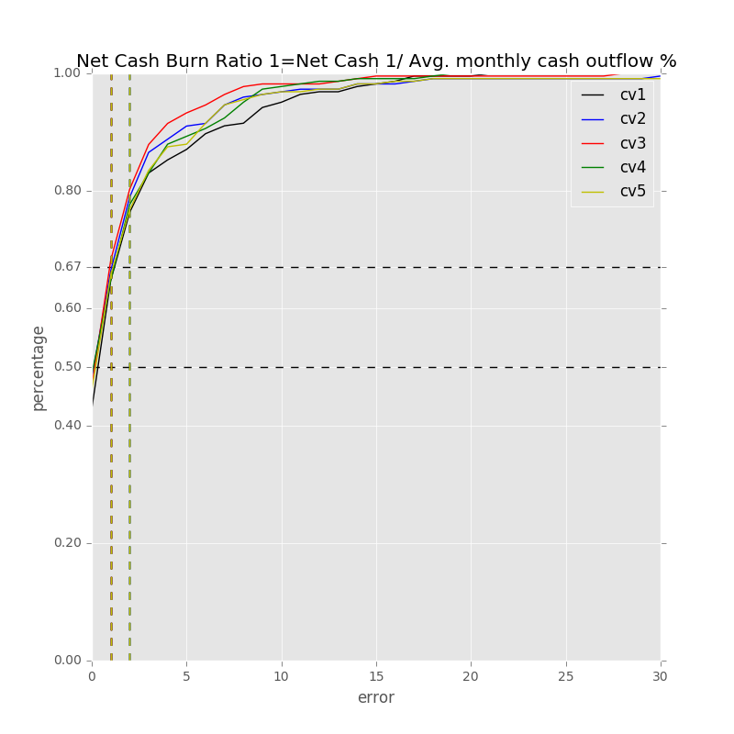

Label: Net Cash Burn Ratio 1=Net Cash 1/ Avg. monthly cash outflow %

Min Error: 0.002307

Mean Error: 2.591844

Median Error: 1.226001

Max Error: 21.807226

Feature importance:

Net Income Margin % : 0.038592

Total Liabilities/Total Assets % : 0.037496

Rev YOY % : 0.035985

Cash from Ops./Net Income% : 0.033882

EBITDA Margin % : 0.033139

Net Property, Plant & Equipment/ Total Assets % : 0.032710

Cash from Ops./EBITDA % : 0.032245

Return on Equity % : 0.032011

Return on Assets % : 0.031558

Total Debt/Equity % : 0.030437

Avg. Days Payable Out. (Days): 0.029549

Avg. Cash Conversion Cycle (Days): 0.028981

Total Asset Turnover : 0.028662

Capital Expenditure ($USDmm, Current rate): 0.027833

Gross Margin % : 0.027376

Total Liabilities ($USDmm, Current rate): 0.027328

Total Revenue ($USDmm, Current rate): 0.026237

Avg. Days Sales Out. (Days): 0.026167

Net Income ($USDmm, Current rate): 0.025893

Other Operating Exp. Total ($USDmm, Current rate): 0.025697

Net Property, Plant & Equipment ($USDmm, Current rate): 0.025455

Avg. Days Inventory Out. (Days): 0.025289

EBITDA ($USDmm, Current rate): 0.024825

R&D Exp./Total Revenue % : 0.023975

Total Assets ($USDmm, Current rate): 0.023775

Depreciation & Amort., Total ($USDmm, Current rate): 0.023391

Goodwill/Total Revenue % : 0.023296

Cash from Ops. ($USDmm, Current rate): 0.023289

Cost Of Goods Sold ($USDmm, Current rate): 0.021948

Repurchase of Common Stock ($USDmm, Current rate): 0.021417

R&D Exp. ($USDmm, Current rate): 0.019942

Payout Ratio (%): 0.019690

Goodwill ($USDmm, Current rate): 0.019480

Cash Acquisitions/Total Revenue % : 0.019431

Cash Acquisitions ($USDmm, Current rate): 0.017484

Number of Employees / Total Revenue [LTM] (Latest): 0.016830

Year Founded: 0.015987

Issuer Credit Rating - Foreign Currency LT [Latest] (Rating): 0.007889

准入资本市场难度: 0.004258

Industry Dummy: 0.003343

Development Phase : 0.002915

Cash flow risk(0:low; 1: high): 0.002579

Share Bonus : 0.001736

Label: Net Cash Burn Ratio 1=Net Cash 1/ Avg. monthly cash outflow %

Min Error: 0.000374

Mean Error: 2.551138

Median Error: 1.101294

Max Error: 41.637333

Feature importance:

Rev YOY % : 0.041380

Total Liabilities/Total Assets % : 0.037115

Cash from Ops./Net Income% : 0.034582

Cash from Ops./EBITDA % : 0.033664

Return on Assets % : 0.032376

Avg. Days Payable Out. (Days): 0.031798

EBITDA Margin % : 0.030686

Net Income Margin % : 0.030576

Gross Margin % : 0.030441

Avg. Days Sales Out. (Days): 0.030300

Total Debt/Equity % : 0.029534

Net Property, Plant & Equipment/ Total Assets % : 0.029440

Avg. Cash Conversion Cycle (Days): 0.029380

Capital Expenditure ($USDmm, Current rate): 0.028478

Total Liabilities ($USDmm, Current rate): 0.027857

Return on Equity % : 0.027854

Total Asset Turnover : 0.027748

Cost Of Goods Sold ($USDmm, Current rate): 0.026837

R&D Exp./Total Revenue % : 0.025250

Cash from Ops. ($USDmm, Current rate): 0.025090

Other Operating Exp. Total ($USDmm, Current rate): 0.024496

Net Property, Plant & Equipment ($USDmm, Current rate): 0.024484

Avg. Days Inventory Out. (Days): 0.024189

Net Income ($USDmm, Current rate): 0.024088

Total Revenue ($USDmm, Current rate): 0.023944

EBITDA ($USDmm, Current rate): 0.023860

Total Assets ($USDmm, Current rate): 0.023632

Depreciation & Amort., Total ($USDmm, Current rate): 0.023625

Goodwill/Total Revenue % : 0.022820

Repurchase of Common Stock ($USDmm, Current rate): 0.020785

Cash Acquisitions ($USDmm, Current rate): 0.020365

Payout Ratio (%): 0.020257

Cash Acquisitions/Total Revenue % : 0.019509

Goodwill ($USDmm, Current rate): 0.018960

R&D Exp. ($USDmm, Current rate): 0.018911

Number of Employees / Total Revenue [LTM] (Latest): 0.018184

Year Founded: 0.015024

Issuer Credit Rating - Foreign Currency LT [Latest] (Rating): 0.008452

准入资本市场难度: 0.004084

Industry Dummy: 0.003284

Development Phase : 0.002501

Cash flow risk(0:low; 1: high): 0.002298

Share Bonus : 0.001863

Label: Net Cash Burn Ratio 1=Net Cash 1/ Avg. monthly cash outflow %

Min Error: 0.000432

Mean Error: 2.163179

Median Error: 1.107130

Max Error: 41.048248

Feature importance:

Net Income Margin % : 0.038773

Total Liabilities/Total Assets % : 0.035832

Rev YOY % : 0.035373

Return on Assets % : 0.034292

Gross Margin % : 0.032629

Cash from Ops./Net Income% : 0.032102

Net Property, Plant & Equipment/ Total Assets % : 0.031655

Cash from Ops./EBITDA % : 0.031502

Total Asset Turnover : 0.031123

Total Debt/Equity % : 0.030248

EBITDA Margin % : 0.030048

Avg. Days Sales Out. (Days): 0.029945

Total Liabilities ($USDmm, Current rate): 0.028929

Return on Equity % : 0.028510

Avg. Cash Conversion Cycle (Days): 0.027870

Capital Expenditure ($USDmm, Current rate): 0.027540

Total Revenue ($USDmm, Current rate): 0.026415

Other Operating Exp. Total ($USDmm, Current rate): 0.026216

Avg. Days Payable Out. (Days): 0.025708

R&D Exp./Total Revenue % : 0.024857

Net Income ($USDmm, Current rate): 0.024347

Cost Of Goods Sold ($USDmm, Current rate): 0.024206

Total Assets ($USDmm, Current rate): 0.024040

Goodwill/Total Revenue % : 0.023839

Avg. Days Inventory Out. (Days): 0.023067

Cash from Ops. ($USDmm, Current rate): 0.023031

EBITDA ($USDmm, Current rate): 0.023027

Net Property, Plant & Equipment ($USDmm, Current rate): 0.021824

Goodwill ($USDmm, Current rate): 0.021800

Repurchase of Common Stock ($USDmm, Current rate): 0.021748

Depreciation & Amort., Total ($USDmm, Current rate): 0.021433

Payout Ratio (%): 0.021283

Cash Acquisitions/Total Revenue % : 0.020685

Cash Acquisitions ($USDmm, Current rate): 0.019462

R&D Exp. ($USDmm, Current rate): 0.018671

Number of Employees / Total Revenue [LTM] (Latest): 0.018379

Year Founded: 0.015986

Issuer Credit Rating - Foreign Currency LT [Latest] (Rating): 0.007473

准入资本市场难度: 0.005220

Development Phase : 0.003506

Industry Dummy: 0.003241

Cash flow risk(0:low; 1: high): 0.002423

Share Bonus : 0.001742

Label: Net Cash Burn Ratio 1=Net Cash 1/ Avg. monthly cash outflow %

Min Error: 0.000489

Mean Error: 2.243335

Median Error: 1.051063

Max Error: 19.723561

Feature importance:

Net Income Margin % : 0.038573

Total Liabilities/Total Assets % : 0.037745

Rev YOY % : 0.034667

Gross Margin % : 0.032573

Cash from Ops./EBITDA % : 0.032573

Avg. Days Payable Out. (Days): 0.031466

Net Property, Plant & Equipment/ Total Assets % : 0.031059

Total Asset Turnover : 0.030998

Cash from Ops./Net Income% : 0.030548

Total Debt/Equity % : 0.030242

Return on Assets % : 0.029747

Avg. Cash Conversion Cycle (Days): 0.029338

EBITDA Margin % : 0.029335

Avg. Days Sales Out. (Days): 0.029196

Total Assets ($USDmm, Current rate): 0.027677

Other Operating Exp. Total ($USDmm, Current rate): 0.027424

Net Property, Plant & Equipment ($USDmm, Current rate): 0.026560

Total Liabilities ($USDmm, Current rate): 0.026348

Return on Equity % : 0.025669

Cost Of Goods Sold ($USDmm, Current rate): 0.025624

Cash from Ops. ($USDmm, Current rate): 0.025342

Net Income ($USDmm, Current rate): 0.025085

Capital Expenditure ($USDmm, Current rate): 0.024706

Goodwill/Total Revenue % : 0.024276

Avg. Days Inventory Out. (Days): 0.024169

Total Revenue ($USDmm, Current rate): 0.023949

Depreciation & Amort., Total ($USDmm, Current rate): 0.023610

Repurchase of Common Stock ($USDmm, Current rate): 0.023477

EBITDA ($USDmm, Current rate): 0.022902

R&D Exp./Total Revenue % : 0.022794

Goodwill ($USDmm, Current rate): 0.020639

Cash Acquisitions/Total Revenue % : 0.020110

Payout Ratio (%): 0.018514

Cash Acquisitions ($USDmm, Current rate): 0.018313

Year Founded: 0.017902

R&D Exp. ($USDmm, Current rate): 0.017101

Number of Employees / Total Revenue [LTM] (Latest): 0.016423

Issuer Credit Rating - Foreign Currency LT [Latest] (Rating): 0.008348

准入资本市场难度: 0.004517

Industry Dummy: 0.003421

Development Phase : 0.002666

Cash flow risk(0:low; 1: high): 0.002287

Share Bonus : 0.002084

Label: Net Cash Burn Ratio 1=Net Cash 1/ Avg. monthly cash outflow %

Min Error: 0.000056

Mean Error: 2.483755

Median Error: 1.244244

Max Error: 40.791579

Feature importance:

Cash from Ops./Net Income% : 0.038046

Total Liabilities/Total Assets % : 0.037015

Net Income Margin % : 0.036719

Rev YOY % : 0.035657

Avg. Days Sales Out. (Days): 0.033732

Cash from Ops./EBITDA % : 0.031751

Net Property, Plant & Equipment/ Total Assets % : 0.031708

Total Debt/Equity % : 0.030915

EBITDA Margin % : 0.030637

Gross Margin % : 0.030555

Total Asset Turnover : 0.029515

Total Liabilities ($USDmm, Current rate): 0.029439

Return on Assets % : 0.029005

Avg. Cash Conversion Cycle (Days): 0.028705

Other Operating Exp. Total ($USDmm, Current rate): 0.028357

Avg. Days Payable Out. (Days): 0.027599

Return on Equity % : 0.027156

Capital Expenditure ($USDmm, Current rate): 0.027025

Cost Of Goods Sold ($USDmm, Current rate): 0.026410

Cash from Ops. ($USDmm, Current rate): 0.025353

R&D Exp./Total Revenue % : 0.025190

Goodwill/Total Revenue % : 0.025099

Total Revenue ($USDmm, Current rate): 0.024962

Total Assets ($USDmm, Current rate): 0.024932

Net Property, Plant & Equipment ($USDmm, Current rate): 0.024881

Depreciation & Amort., Total ($USDmm, Current rate): 0.022901

Net Income ($USDmm, Current rate): 0.022666

EBITDA ($USDmm, Current rate): 0.022328

Avg. Days Inventory Out. (Days): 0.022017

Repurchase of Common Stock ($USDmm, Current rate): 0.021215

Cash Acquisitions ($USDmm, Current rate): 0.020698

Cash Acquisitions/Total Revenue % : 0.020095

Payout Ratio (%): 0.019057

Goodwill ($USDmm, Current rate): 0.019043

Number of Employees / Total Revenue [LTM] (Latest): 0.017459

R&D Exp. ($USDmm, Current rate): 0.016653

Year Founded: 0.015835

Issuer Credit Rating - Foreign Currency LT [Latest] (Rating): 0.007347

Development Phase : 0.003055

准入资本市场难度: 0.002995

Industry Dummy: 0.002898

Cash flow risk(0:low; 1: high): 0.001705

Share Bonus : 0.001672

Total Min: 0.000732

Total Mean: 2.406650

Total Median: 1.145946

Total Max: 33.001589

## 模型7

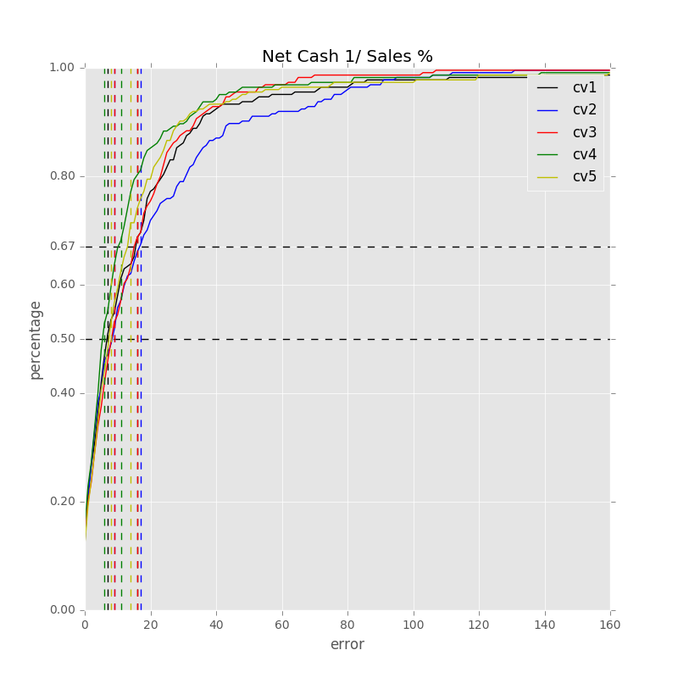

Label: Net Cash 1/ Sales %

Min Error: 0.033464

Mean Error: 17.492814

Median Error: 7.571626

Max Error: 231.312392

Feature importance:

Cash from Ops./Net Income% : 0.035959

Net Income Margin % : 0.035704

Total Liabilities/Total Assets % : 0.035367

Rev YOY % : 0.034717

Total Debt/Equity % : 0.033256

Net Property, Plant & Equipment/ Total Assets % : 0.032217

Cash from Ops./EBITDA % : 0.031445

Return on Assets % : 0.030886

Gross Margin % : 0.030113

Total Asset Turnover : 0.029971

Avg. Cash Conversion Cycle (Days): 0.029912

Avg. Days Payable Out. (Days): 0.029112

EBITDA Margin % : 0.028671

Other Operating Exp. Total ($USDmm, Current rate): 0.028386

Avg. Days Sales Out. (Days): 0.028191

Net Income ($USDmm, Current rate): 0.026630

Return on Equity % : 0.026451

Total Liabilities ($USDmm, Current rate): 0.025391

EBITDA ($USDmm, Current rate): 0.025376

R&D Exp./Total Revenue % : 0.025369

Total Revenue ($USDmm, Current rate): 0.025326

Net Property, Plant & Equipment ($USDmm, Current rate): 0.025155

Total Assets ($USDmm, Current rate): 0.024935

Capital Expenditure ($USDmm, Current rate): 0.024681

Avg. Days Inventory Out. (Days): 0.024161

Depreciation & Amort., Total ($USDmm, Current rate): 0.023894

Repurchase of Common Stock ($USDmm, Current rate): 0.023081

Cost Of Goods Sold ($USDmm, Current rate): 0.022497

Goodwill/Total Revenue % : 0.022417

Goodwill ($USDmm, Current rate): 0.020765

Cash Acquisitions/Total Revenue % : 0.020623

Cash from Ops. ($USDmm, Current rate): 0.020622

Cash Acquisitions ($USDmm, Current rate): 0.020040

Number of Employees / Total Revenue [LTM] (Latest): 0.019552

Payout Ratio (%): 0.018554

R&D Exp. ($USDmm, Current rate): 0.017802

Year Founded: 0.017555

Issuer Credit Rating - Foreign Currency LT [Latest] (Rating): 0.009115

准入资本市场难度: 0.004513

Development Phase : 0.004041

Industry Dummy: 0.003439

Cash flow risk(0:low; 1: high): 0.002376

Share Bonus : 0.001732

Label: Net Cash 1/ Sales %

Min Error: 0.005358

Mean Error: 19.111084

Median Error: 9.177926

Max Error: 202.216191

Feature importance:

Rev YOY % : 0.038527

Net Income Margin % : 0.037573

Total Liabilities/Total Assets % : 0.035260

Cash from Ops./EBITDA % : 0.034657

Return on Assets % : 0.033451

Cash from Ops./Net Income% : 0.031833

Total Debt/Equity % : 0.031515

Net Property, Plant & Equipment/ Total Assets % : 0.030674

Total Asset Turnover : 0.030477

Gross Margin % : 0.030367

Avg. Days Sales Out. (Days): 0.030254

EBITDA Margin % : 0.029114

Total Revenue ($USDmm, Current rate): 0.028088

Avg. Cash Conversion Cycle (Days): 0.027895

Capital Expenditure ($USDmm, Current rate): 0.027759

Total Liabilities ($USDmm, Current rate): 0.027728

Avg. Days Payable Out. (Days): 0.027281

Total Assets ($USDmm, Current rate): 0.026125

Other Operating Exp. Total ($USDmm, Current rate): 0.026104

Return on Equity % : 0.025672

EBITDA ($USDmm, Current rate): 0.024939

Avg. Days Inventory Out. (Days): 0.024414

R&D Exp./Total Revenue % : 0.023734

Cash from Ops. ($USDmm, Current rate): 0.023375

Cost Of Goods Sold ($USDmm, Current rate): 0.023075

Goodwill/Total Revenue % : 0.023065

Depreciation & Amort., Total ($USDmm, Current rate): 0.023013

Net Income ($USDmm, Current rate): 0.022824

Net Property, Plant & Equipment ($USDmm, Current rate): 0.022125

Goodwill ($USDmm, Current rate): 0.021386

Cash Acquisitions/Total Revenue % : 0.020856

Payout Ratio (%): 0.020606

Repurchase of Common Stock ($USDmm, Current rate): 0.020177

Number of Employees / Total Revenue [LTM] (Latest): 0.020104

Year Founded: 0.017727

Cash Acquisitions ($USDmm, Current rate): 0.017536

R&D Exp. ($USDmm, Current rate): 0.017525

Issuer Credit Rating - Foreign Currency LT [Latest] (Rating): 0.008009

准入资本市场难度: 0.004374

Development Phase : 0.003748

Industry Dummy: 0.003298

Share Bonus : 0.002007

Cash flow risk(0:low; 1: high): 0.001727

Label: Net Cash 1/ Sales %

Min Error: 0.012832

Mean Error: 15.369649

Median Error: 9.236908

Max Error: 234.664919

Feature importance:

Total Liabilities/Total Assets % : 0.036929

Net Income Margin % : 0.035976

Rev YOY % : 0.035894

Cash from Ops./Net Income% : 0.033634

Net Property, Plant & Equipment/ Total Assets % : 0.033368

Cash from Ops./EBITDA % : 0.032977

Return on Assets % : 0.030939

Total Debt/Equity % : 0.029919

Avg. Days Sales Out. (Days): 0.029819

EBITDA Margin % : 0.029810

Capital Expenditure ($USDmm, Current rate): 0.029456

Total Liabilities ($USDmm, Current rate): 0.028514

Gross Margin % : 0.028102

Return on Equity % : 0.027824

Avg. Days Payable Out. (Days): 0.027743

Avg. Cash Conversion Cycle (Days): 0.027656

Other Operating Exp. Total ($USDmm, Current rate): 0.027625

Total Asset Turnover : 0.027574

Total Assets ($USDmm, Current rate): 0.026669

Total Revenue ($USDmm, Current rate): 0.026667

Net Income ($USDmm, Current rate): 0.025823

Depreciation & Amort., Total ($USDmm, Current rate): 0.025110

Avg. Days Inventory Out. (Days): 0.024970

Net Property, Plant & Equipment ($USDmm, Current rate): 0.024883

Cash from Ops. ($USDmm, Current rate): 0.024782

R&D Exp./Total Revenue % : 0.024445

Goodwill/Total Revenue % : 0.023887

EBITDA ($USDmm, Current rate): 0.023450

Cost Of Goods Sold ($USDmm, Current rate): 0.022765

Repurchase of Common Stock ($USDmm, Current rate): 0.022140

Cash Acquisitions ($USDmm, Current rate): 0.020130

Goodwill ($USDmm, Current rate): 0.019820

Payout Ratio (%): 0.019171

Cash Acquisitions/Total Revenue % : 0.018257

Number of Employees / Total Revenue [LTM] (Latest): 0.017245

R&D Exp. ($USDmm, Current rate): 0.016232

Year Founded: 0.015978

Issuer Credit Rating - Foreign Currency LT [Latest] (Rating): 0.008946

准入资本市场难度: 0.004093

Development Phase : 0.003707

Industry Dummy: 0.003496

Cash flow risk(0:low; 1: high): 0.002177

Share Bonus : 0.001399

Label: Net Cash 1/ Sales %

Min Error: 0.026894

Mean Error: 43.480532

Median Error: 6.635000

Max Error: 6663.553679

Feature importance:

Total Liabilities/Total Assets % : 0.038392

Net Income Margin % : 0.036923

Rev YOY % : 0.035200

Net Property, Plant & Equipment/ Total Assets % : 0.034423

Cash from Ops./Net Income% : 0.033585

Cash from Ops./EBITDA % : 0.033464

Return on Assets % : 0.032409

Gross Margin % : 0.030946

Avg. Days Payable Out. (Days): 0.030440

Avg. Days Sales Out. (Days): 0.030365

Total Debt/Equity % : 0.030344

Other Operating Exp. Total ($USDmm, Current rate): 0.030090

Avg. Cash Conversion Cycle (Days): 0.029438

Total Asset Turnover : 0.028949

EBITDA Margin % : 0.027857

Total Liabilities ($USDmm, Current rate): 0.027471

Total Revenue ($USDmm, Current rate): 0.026367

Capital Expenditure ($USDmm, Current rate): 0.025962

Net Income ($USDmm, Current rate): 0.025201

Avg. Days Inventory Out. (Days): 0.025109

R&D Exp./Total Revenue % : 0.025056

Cash from Ops. ($USDmm, Current rate): 0.024998

Return on Equity % : 0.024812

Cost Of Goods Sold ($USDmm, Current rate): 0.024284

Goodwill/Total Revenue % : 0.024241

EBITDA ($USDmm, Current rate): 0.023658

Net Property, Plant & Equipment ($USDmm, Current rate): 0.022740

Repurchase of Common Stock ($USDmm, Current rate): 0.021859

Total Assets ($USDmm, Current rate): 0.021660

Goodwill ($USDmm, Current rate): 0.020434

Depreciation & Amort., Total ($USDmm, Current rate): 0.020094

Cash Acquisitions/Total Revenue % : 0.019555

Cash Acquisitions ($USDmm, Current rate): 0.019466

Payout Ratio (%): 0.019204

R&D Exp. ($USDmm, Current rate): 0.018425

Number of Employees / Total Revenue [LTM] (Latest): 0.018318

Year Founded: 0.015826

Issuer Credit Rating - Foreign Currency LT [Latest] (Rating): 0.008328

Industry Dummy: 0.003572

准入资本市场难度: 0.003498

Development Phase : 0.003496

Share Bonus : 0.002143

Cash flow risk(0:low; 1: high): 0.001396

Label: Net Cash 1/ Sales %

Min Error: 0.014035

Mean Error: 15.700095

Median Error: 8.335697

Max Error: 229.200759

Feature importance:

Rev YOY % : 0.038722

Cash from Ops./Net Income% : 0.037052

Total Liabilities/Total Assets % : 0.036949

Net Income Margin % : 0.035627

Cash from Ops./EBITDA % : 0.033063

Net Property, Plant & Equipment/ Total Assets % : 0.032559

Return on Assets % : 0.031048

Avg. Days Sales Out. (Days): 0.030899

Total Debt/Equity % : 0.030564

Total Asset Turnover : 0.030253

Avg. Cash Conversion Cycle (Days): 0.029240

Total Revenue ($USDmm, Current rate): 0.029185

Other Operating Exp. Total ($USDmm, Current rate): 0.028574

Capital Expenditure ($USDmm, Current rate): 0.028234

EBITDA Margin % : 0.027632

Return on Equity % : 0.027112

Gross Margin % : 0.026282

Avg. Days Payable Out. (Days): 0.025476

Total Liabilities ($USDmm, Current rate): 0.025474

Total Assets ($USDmm, Current rate): 0.025293

R&D Exp./Total Revenue % : 0.024435

Net Property, Plant & Equipment ($USDmm, Current rate): 0.024020

EBITDA ($USDmm, Current rate): 0.023727

Goodwill/Total Revenue % : 0.023719

Net Income ($USDmm, Current rate): 0.023432

Repurchase of Common Stock ($USDmm, Current rate): 0.023338

Cash Acquisitions/Total Revenue % : 0.023179

Cash from Ops. ($USDmm, Current rate): 0.022883

Avg. Days Inventory Out. (Days): 0.022538

Cost Of Goods Sold ($USDmm, Current rate): 0.021848

Depreciation & Amort., Total ($USDmm, Current rate): 0.021785

Cash Acquisitions ($USDmm, Current rate): 0.019966

Number of Employees / Total Revenue [LTM] (Latest): 0.019869

Goodwill ($USDmm, Current rate): 0.019502

R&D Exp. ($USDmm, Current rate): 0.019128

Year Founded: 0.017301

Payout Ratio (%): 0.017214

Issuer Credit Rating - Foreign Currency LT [Latest] (Rating): 0.007878

准入资本市场难度: 0.003803

Industry Dummy: 0.003582

Development Phase : 0.003501

Share Bonus : 0.002403

Cash flow risk(0:low; 1: high): 0.001708

Total Min: 0.018517

Total Mean: 22.230835

Total Median: 8.191431

Total Max: 1512.189588